ELEC 2210 LABORATORY REPORT COVER PAGE

Please Let Me Know if I keep having to include this page and edit it or can I use the Title Page I made below right after this page. Comment on canvas. Thanks

Meeting # 002 Experiment 1: Basic Digital Logic CIrcuits

*Title of Lab Experiment*

Student Name: Howard Jacob, A

*Name (Last, First, MI)*

Student Email: JAH0147

*AU 7-character username*

GTA: Jonathan

*Name of your GTA*

Section you are enrolled in: (Circle One): 1 2 3 4 5 6 7 8

Date experiment performed (dd / mm / yy): *20/10/20*

Date report submitted: (dd / mm / yy): *27/10/20*

If you performed this experiment at a time other than your regularly scheduled section meeting:

Section # of the section you sat in on (Circle One): 1 2 3 4 5 6 7 8 Makeup

Name of the GTA who supervised your work: __________________________

I hereby certify that the contents of this report are true and complete to the best of my ability. The lab work was performed by me exclusively, and this report was written by me exclusively.

*Jacob Howard* 20/10/20

Student signature Date signed

ELEC-2210

Digital Electronics

FROM: Jacob Howard

TO: Yili “Jonathan” Wang

LAB DATE: 10/20/20

DUE DATE: 10/27/20

LAB SECTION: 002 (Tuesday, 1:00pm-2:50 pm)

EXPERIMENT 9:

MOSFETs and CMOS Inverter

# **Introduction**

# For this week’s laboratory experiment we used chips containing MOSFETs and CMOS. Our goal was to measure current and voltage in a forced saturation configuration and to build a CMOS inverter.

# **Step 1**

For Step 1, we were to construct the circuit shown in *Figure 1* on the ELVIS Board. After constructing the circuit, we were to use the provided LabView program to produce the graphs and find the required measurements. The first graph shows the NMOS Ids-Vds curve and the second graph shows the NMOS Ids-Vgs curve. The graphs are shown in *Figure 2 and 3* and the data is shown in Table 1 below.

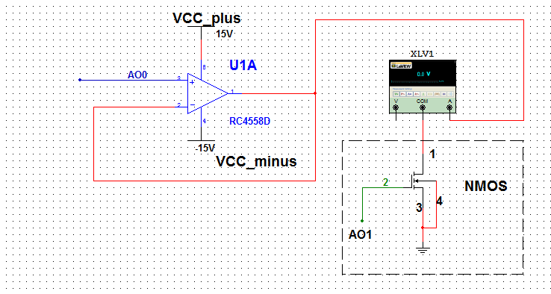

*Figure 1*

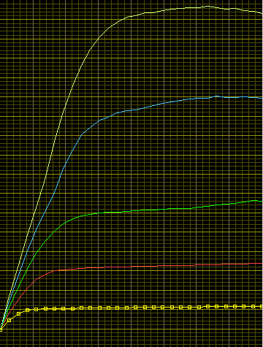

*Figure 2*

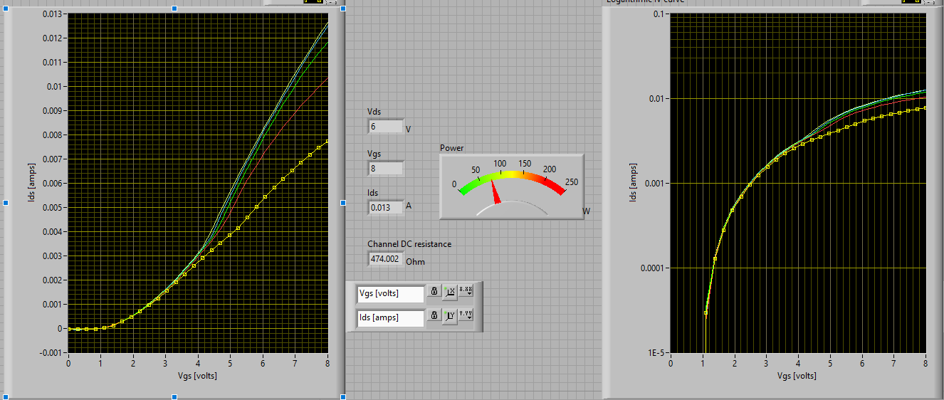

*Figure 3*

# **Step 2**

# For Part 2, we removed all connections from the previous circuit and constructed a new circuit from *Figure 4.* We then downloaded and opened the provided LabView program to get the PMOS Ids-Vds curve. The graph is shown in *Figure 5* below. We then used another LabView program to find the Ids-Vgs curve. The Ids-Vgs curve is shown in *Figure 6*.

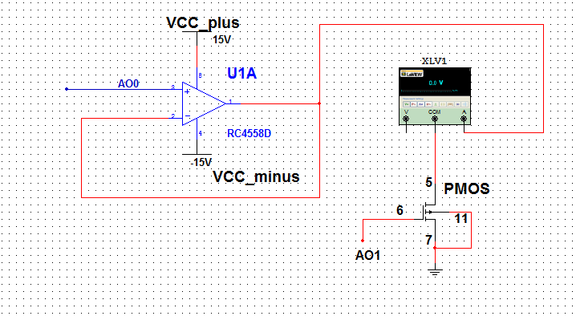

*Figure 4*

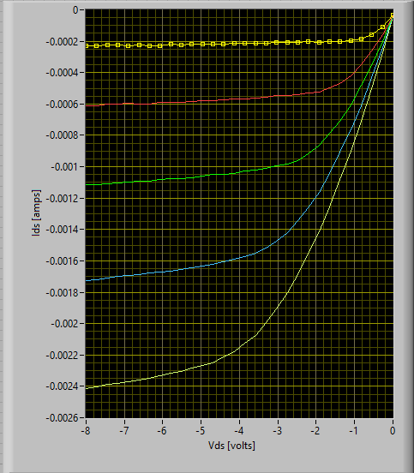

*Figure 5*

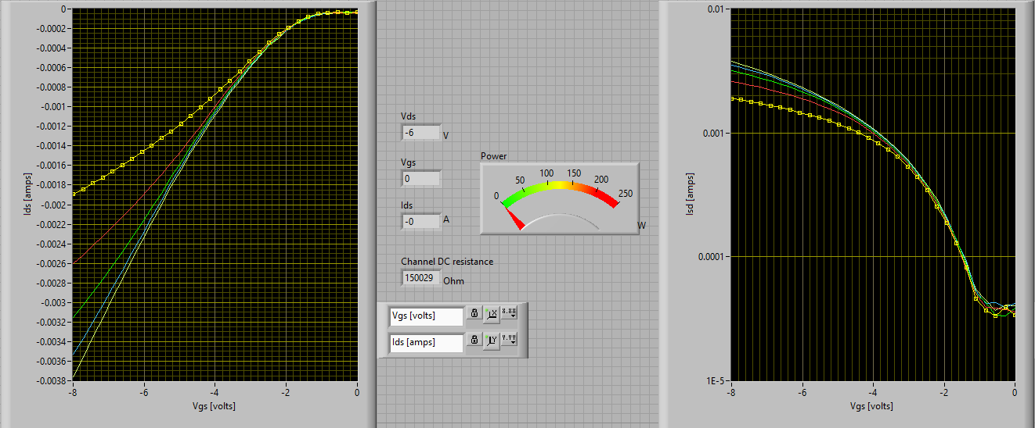

*Figure 6*

# **Step 3**

For Step 3, we were asked to construct a CMOS inverter using the ALD1105 chip. The circuit we were to construct is shown in Figure 6. We used the Function Generator to set the frequency. We then used the Oscilloscope to see the output of the circuit. We were asked to provide the output at 5v, 7v, very low frequency, and very high frequency. All outputs and shown in *Figures 7-10* below.

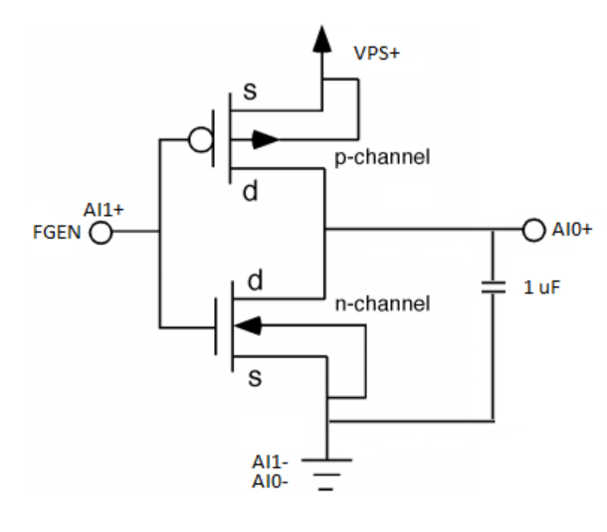

*Figure 6*

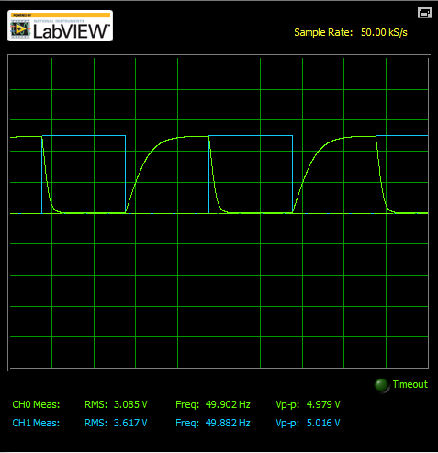

*Figure 7 (5v)*

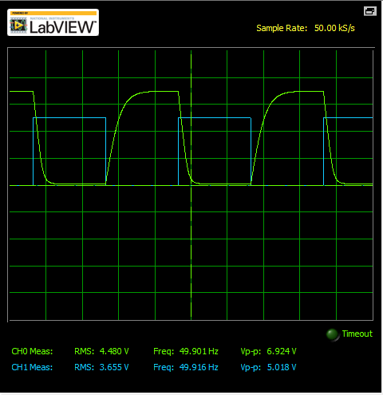

*Figure 8 (7v)*

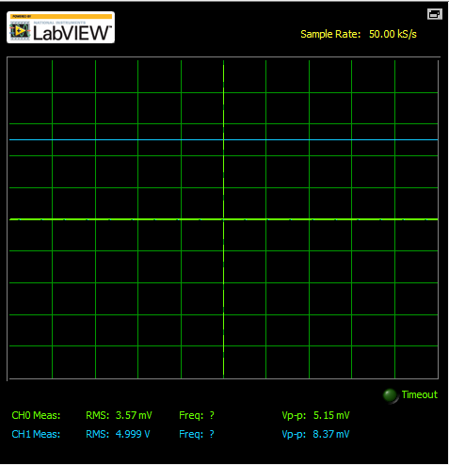

*Figure 9 (low frequency)*

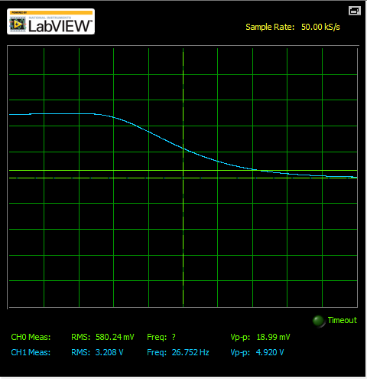

*Figure 10 (High Frequency*

# **Step 4**

For Step 4, we to measure the voltage transfer curve using the LabView program provided. We were asked to remove the capacitor from the previous constructed circuit and set the VPS to 5v. The circuit we constructed can be viewed by the diagram in *Figure 11*. We used the LabView program to obtain the graph and data. The graph can be seen in *Figure 12* and the Data can bee seen in *Data 1*.

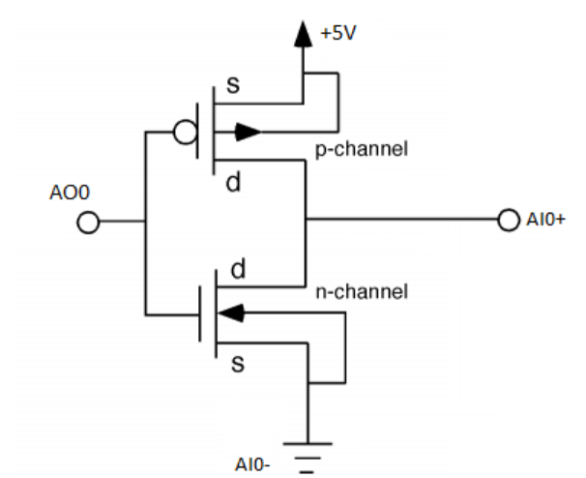

*Figure 11*

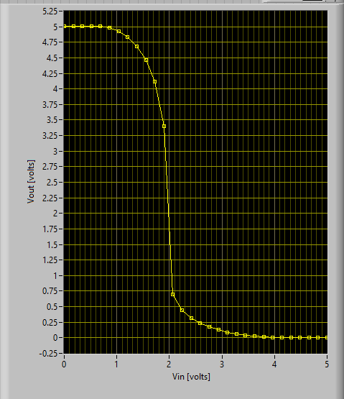

*Figure 12*



*Data 1*

# **Step 5**

Step 5 was a bonus step and I did not complete it

# **Conclusion**

In Conclusion, this lab was very interesting. This was our first lab with MOSFETs and and CMOS circuits. I found it very helpful to understand how the circuits work by constructing them hands-on.